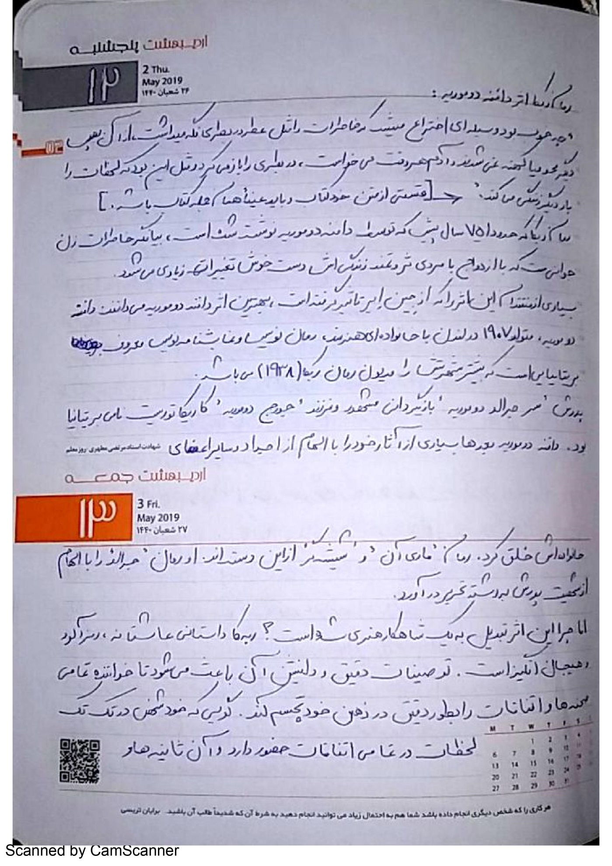

***Rebecca's novel by Domoria***

How good it was to invent a device that would preserve memories like a perfume in a bottle, because it was no longer conceptual or obsolete. Everyone wanted to open the bottle and it was as if they were reviving the moment.

Rebecca's novel, written about 75 years ago by Domain Dumourie, chronicles the memories of a young woman who changes her life by marrying a rich man.

Many critics of this work, using Jane Eyre, are the best work of the second domain of the Monastery of the Second Groom, born in 1907 in London, with the family of the famous British artist, novelist and author, most of whose fame is due to Rebecca 1938.His father, Sir Gerald Dumourier, was a famous British actor and the son of George Dumourier, a famous British cartoonist.

His father, Sir Gerald Dumourier, was a famous British actor and the son of George Dumourier, a famous British cartoonist.

Domane Dumourier later created many of his works inspired by his ancestors and other family members. Marie Ann's novel The Glassmaker belongs to this category. He wrote the novel Daring inspired by his father's character.

But why has this work become a masterpiece of art ?? Rebecca is a love story, mysterious and exciting. Its precise and pleasant descriptions make the reader visualize all the scenes and events in his mind accurately, as if he himself is present in every moment of every event and those seconds. And it lives the minutes, and this is what motivates the reader to follow the novel to the end. This novel is really full of interesting and wonderful surprises to the extent that it makes the reader make an early judgment and then breaks all his mental equations. And he is surprised that Rebecca's novel is narrated by a young woman whose name we do not understand until the end of the story and remains unknown. The narrator is a young and poor woman who lives with her master. Her master is a rich and well-to-do woman who spends all her time traveling to different places for fun and entertainment. One day on one of these trips to a summer hotel, a young girl meets a wealthy middle-aged man named Maxim Dovinter.

Some time later, Maxim proposes to the young girl, and in disbelief, he marries the rich Duvinter, and they go to Mandoli's palace together. He had married Rebecca before her, but that was not the whole story ...